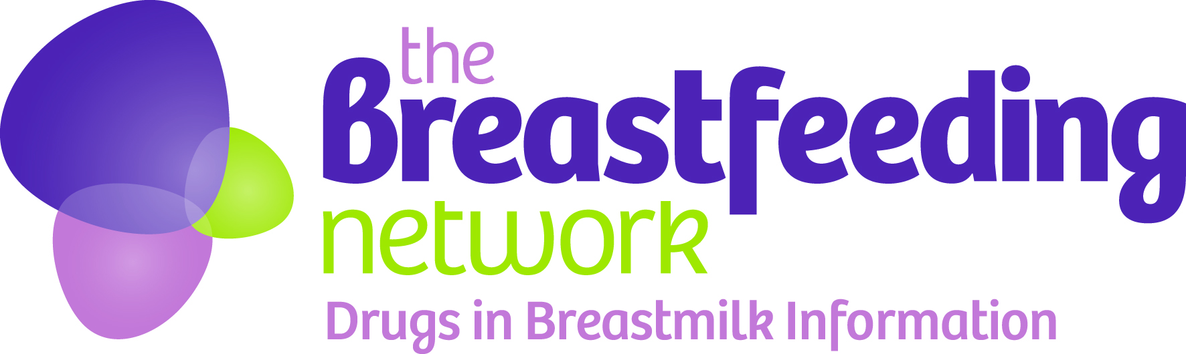
Application form – Friends of Drugs in Breastmilk Helpline scheme

Please email your completed form to friendsofDIBM@breastfeedingnetwork.org.uk or post it to The Breastfeeding Network, Friends of Drugs in Breastmilk scheme, PO Box 11126, Paisley, PA2 8YB
Name

Organisation
(if applicable)
Email address

Address inc. postcode
(to send the Drug infosheets book to)
Is this a gift for someone else? | Yes / No (please delete as appropriate)  If yes please give the details of the person the gift is for  Name  Email  Address  Postcode
Type of membership (Please tick) | Personal £25 per year  Organisation £150 per year
Payment method  (please tick) | Online via www.breasfeedingnetwork.org.uk/shop  Via BACS transfer (details below)  Via cheque – please make cheques payable to The Breastfeeding Network  For organisations only – invoice or purchase order – please give details below:
BACS details for bank transfer  (Include ref. DIBM if possible) | Account name | The Breastfeeding Network
 | Account no. | 06001963
 | Sort code | 80 09 29
Are you happy to have your name included in the supporters page of our newsletter/website? | Yes / No (Please delete as applicable)
Thank you for becoming a Friend of Drugs in Breastmilk helpline.
Your support makes all the difference!

We will keep your details secure and only use them to share information about this scheme. We will not share them with any other organisations. You can ask to be removed from our database by emailing admin@breastfeedingnetwork.org.uk
Please note we cannot accept donations/funding from any company with a commercial interest in infant feeding or any organisation that does not comply with the WHO code on the marketing of breastmilk substitutes

